Kaytlynn’s choza de alimentos
kaytlynn’s food hut

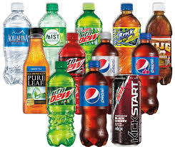
BEBER\DRINKS
$1.36 for drinks
aqua\water (free)
pepsi productos\pepsi productos
limonada\lemonade (pink or regular)
leche\milk (chocolate,strawberry,white)
té\tea (sweet or unsweet)
jugo\juice (apple,orange,grape,pineapple)
café\coffee

APERITIVOS\APPERTIZERS
palitos con queso\cheese sticks ($3.29\\dozen)
patatas fritas y salsa\chips and salsa ($2.19)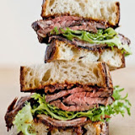
Champiñones fritos\fried mushrooms($3.18)

Desayuno/Breakfast
1 Huevos y 1 tocino\eggs and bacon ($2.43)
2 Panqueques y 1 salchicha\pancakes and sausage ($4.87)
Cereal y fruta ensalada\cereal and fruit salad ($3.00)

Almuerzo/Lunch
Pescado y papas fritas\fish and chips ($6.78)
Torta\sandwhich (jamón,pavo)($2.56)
Sopa\soup (tomate,vegetales) ($2.67)

Cena\Dinner
Hamburguesa\hamburger ($4.67)
Bistec y arroz\steak and rice($4.78)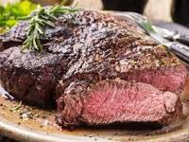
Pollo\chicken($2.89)

kids menu
(2.67)
queso a la parrilo\grilled cheese ($2.67)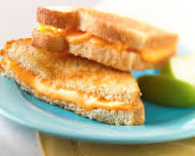
perro de maiz\corn dog
hot dog
fajitos de pollo\chicken strips

